**Assignment 1: Part 1**

**Basic Phone Book Application**

**Introduction**

A phone book is an important and efficient way of keeping phone records and other related information of contacts. This documentation presents a design for a basic phone application that saves, edits, searches, deletes, and retrieves saved records.

Liang (2013) states that data used in a software application is temporary and is lost once the program is terminated unless it is explicitly saved. In order to ensure permanent storage of program-generated data, it is necessary to save it to a file on a disk or other durable storage medium. This file can then be relocated and accessed by various programs at a later point. Data storage and sharing can be accomplished using various methods. Considering a scenario where there are specific strings in one notebook that will need to be used in another, one of the easiest approaches would be to save the strings in a text file and then access it from another notebook. A text file, typically using “.txt” extension, contains only plain text (Kong et al., 2020). The proposed phone book application will use this approach. The phone numbers and contact names will be stored in a text file named “PhoneBook.txt”. The application will then be executed from the command line with easy-to-understand menu options that allow users to register, search, edit, and delete phone numbers.

**Objectives and Purpose**

The objective of this application is to provide a simple interface for managing phone contacts. It aims to help users keep track of their contacts by storing them in a structured and easily accessible format.

**Instruction for execution**

The application starts by loading any existing phone numbers from the “PhoneBook.txt” file into a dictionary. It then displays a menu with six choices for the user. Depending on the user’s choice, it performs one of the following operations:

1. Register a new phone number
2. Search for a phone number
3. Edit phone number
4. Delete a phone record
5. Retrieve all records from the file
6. Quit the application

**Data Structure**

The main data structure used in this application is a dictionary called “numbers”, where the keys are the names, and the values are the phone numbers.

Used in the context of python, a dictionary is a collection of unique key-value pairs. Other programming languages sometimes use “associative memories” or “associative arrays”. An empty dictionary can be created using a pair of braces: {}. To initialize a dictionary, a list of key-value pairs will be placed, separated by commas, within the braces. This is also the standard representation of dictionaries. The primary operations on a dictionary involve storing a value with a specific key and retrieving the value associated with a given key. The key-value pair can be removed using the ‘del’ command. If a value is stored using an existing key, the previous value linked to that key will be replaced. Attempting to retrieve a value with a key that doesn’t exist in the dictionary will result in an error (Van Rossum, 2020).

This approach allows for efficient retrieval, addition, and deletion of phone numbers (Mishra, 2019).

**Test Plan and Expected Results**

The application will be tested at several points for proper functioning and error handling. To test if the application functions properly – the following test plans will be conducted.

|  |  |  |
| --- | --- | --- |
|  | *Test* | *Expected result* |
| 1 | Enter menu choice 1 and register a new phone number: Enter a name and a phone number when prompted. Check the “PhoneBook.txt”. | New record should appear in the “PhoneBook.txt” |
| 2 | Enter menu choice 2 and search for a phone number: Enter a name that exists in the dictionary. | The application should display the corresponding phone number. |
| 3 | Enter menu choice 3 and edit a phone number: Enter a name that exists in the dictionary, then enter a new phone number. Check the “PhoneBook.txt” file. | The new phone number should be added to the existing name in the “PhoneBook.txt”. |
| 4 | Enter menu choice 4 and delete a phone record: Enter a name that exists in the dictionary. Check the “PhoneBook.txt” file to see if the record has been deleted. | The entered record should not appear in the “PhoneBook.txt”. |
| 5 | Enter menu choice 5 and retrieve all records from the file. | The application should display all the names and their corresponding phone numbers in the dictionary. |
| 6 | Enter menu choice 6 to quit the application | The application should close and all changes made during the session should be saved to the “PhoneBook.txt” file. |
| 7 | Enter a number that is not available in the menu choice (e.g “8”). | The application should display “*Invalid Choice*” |
| 8 | Enter menu choice 1 and add a new name to the record. When prompted to add a number add a character (text) value. | The application should display “*Invalid input. Please enter a number:”* |

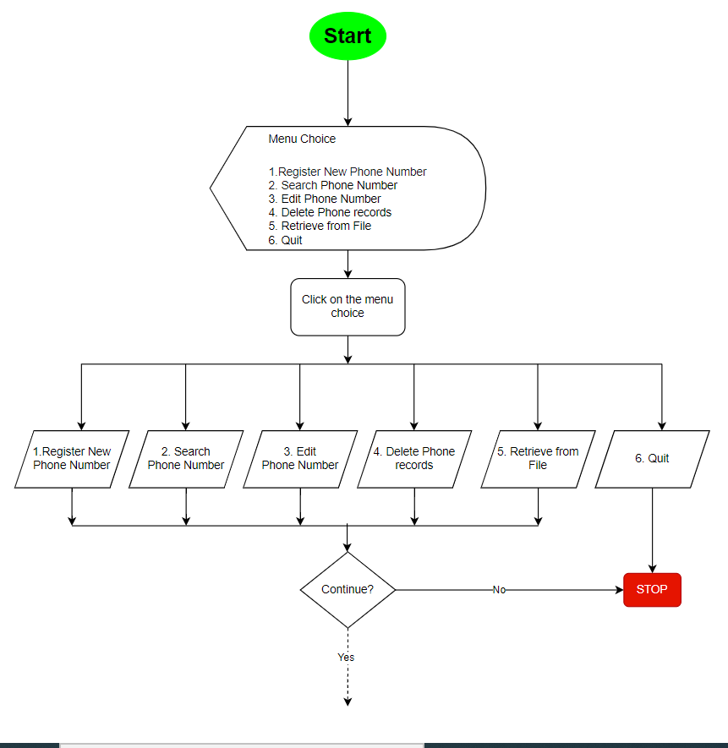**Flow chart and pseudocodes**

Menu Choice #1



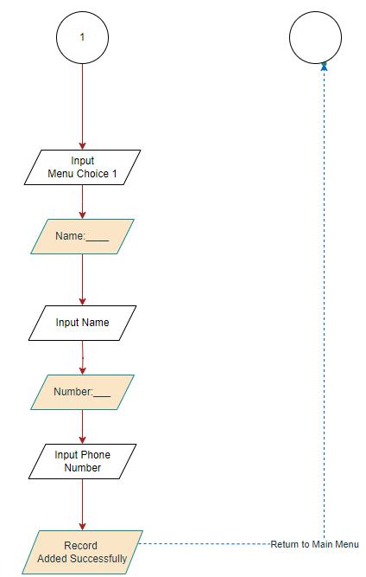

Menu Choice #2



Menu Choice #3



Menu Choice #4

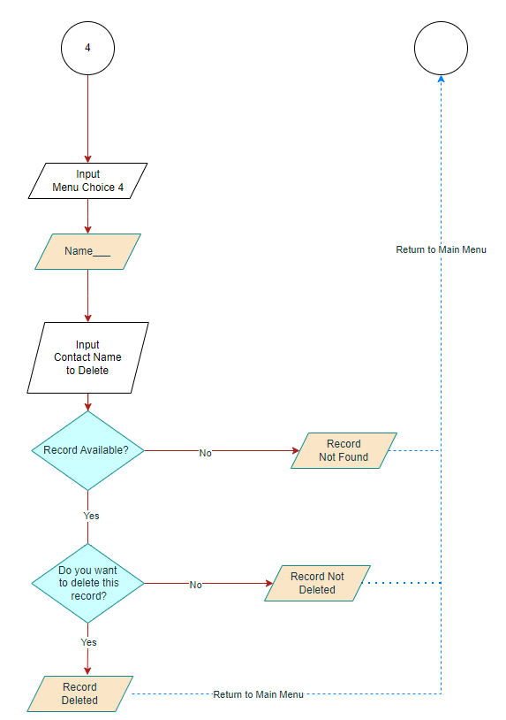



Menu Choice #5

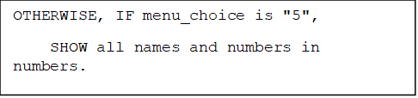

**References**

Kong, Q., Siauw, T. and Bayen, A. (2020). *Python Programming and Numerical Methods A Guide for Engineers and Scientists*. [online] Available at: https://library.samdu.uz/files/8ea2cbd32e87c6d25a17c4b2510501d0_Python_Programming_and_Numerical_Methods_A_Guide_for_Engineers_and.pdf [Accessed 28 Sep. 2023].

Liang, Y.D. (2013). *Introduction to Programming Using Python*. [online] *Google Books*. Pearson. Available at: https://books.google.co.bw/books/about/Introduction_to_Programming_Using_Python.html?id=8qifuAAACAAJ&redir_esc=y [Accessed 28 Sep. 2023].

Mishra, N. (2019). *Create, add, remove and modify Dictionary in Python*. [online] CodeSpeedy. Available at: https://www.codespeedy.com/creation-addition-removal-and-modification-of-dictionary-in-python/ [Accessed 28 Sep. 2023].

Stack Overflow. (n.d.). *Python assignment for a phonebook*. [online] Available at: https://stackoverflow.com/questions/28910134/python-assignment-for-a-phonebook [Accessed 28 Sep. 2023].

Van Rossum, G., 2020. Python Tutorial Release 3.7. 0. *www.academia.edu*. [online] Available at: <https://www.academia.edu/41039821/Python_Tutorial_Release_3_7_0_Guido_van_Rossum_and_the_Python_development_team>.

‌

‌